COMP20008 Assignment 2
Operational Strategy or Listing Fundamentals?
Predicting Superhost Status in the Melbourne Short-Term Rental Market
Group name | W06G02
Group members | Jintao Liu (1582753)  Zhimo Ji (1810362)  Yifangfei Liu (1809764)  Leo Xu (1896121)

Introduction
Research question. Can superhost status be inferred from listing attributes and host operating behaviour once Airbnb's own criteria are excluded, and is it more closely associated with listing fundamentals or operational strategy?
Airbnb awards a special ‘superhost’ status to hosts who meet a published set of criteria, assessed every three months over a twelve-month period: at least 10 completed stays, an overall rating of 4.8 or higher, a 90% response rate within 24 hours, and a cancellation rate below 1% (Airbnb, 2026). The badge is shown to guests and is generally read as a mark of reliability, so hosts have a reason to earn and keep it. This report asks what else, besides the criteria themselves, separates superhosts from other hosts in the Melbourne market. We use the Inside Airbnb Melbourne dataset (Inside Airbnb, 2026), containing 25,728 Airbnb listings within Melbourne. The analysis then follows the RQ through preprocessing, correlation analysis, supervised learning (KNN and Decision Tree), feature selection, PCA and clustering.

Methodology

Data Preprocessing
We proposed and considered six candidate preprocessing steps (Table 1) for the Melbourne Airbnb dataset, aligned with the research question.
Table 1: Candidate preprocessing steps with dataset properties that supported the selection condition, with the corresponding outcome.
# | Candidate step | Properties | Decision
1 | Deriving days_since_last_review from the raw last_review date field | 4,477 rows (17.4%) have no review date at all, and their superhost rate is 6.59% | Selected
2 | Calculate amenity_count by parsing the structured amenities field | Superhosts average 44.08 amentities, non-superhosts 31.03. | Selected
3 | Handle missing price values via median imputation plus a missing indicator variable | 6,553 rows (25.47%) have no price | Selected
4 | Use imputation for missing values in the bedrooms and beds fields | Missing 18.19% for bedrooms and 27.44% for beds, and the missingness is conditional on room type | Rejected
5 | Merge rare categories for the property_type variable | Out of 82 categories, only 41 with under 10 listings (totalling 111 rows) | Rejected
6 | Discretise minimum_nights into grouped equal-width bins (short/long) | Only 426 rows (1.66%) require 30 nights or more | Rejected
Justifications for selections. Deriving days_since_last_review from the raw last_review date field was selected as dropping 4,477 listings no review date (17.4% of all rows) would raise the superhost rate from 30.65% to 35.72%, creating a shift in class balance, thus the model would have an inflated sense of how common superhosts are. Furthermore, 295 superhosts are still present within the no review date group, which is why the rows are worth keeping. Calculating amenity count was selected as amenity count separates superhosts at 44.08 amenities against 31.03 amenities. Amenities are also among the few features a host can change at any time, which places this column on the operational side of the research question. Handling missing price values via imputation was selected as price missingness depends on whether the listing is bookable at all and is missing at random (MAR). 99.85% of listings with zero bookable days have no price, against 2.22% of bookable ones. As delisted listings have an 8.13% superhost rate against 37.68% for active listings, deletion would inflate the superhost rate.
Justifications for rejections. Imputing the bedrooms and beds fields was rejected as data was unfairly split. Bedrooms are missing for 18.19% (beds 27.44%), but the data is split by room type, with entire homes missing 2.47%, private rooms 61.28%. When renting a private room, bedroom count is not relevant, so the host does not fill it in and missingness is justified. Thus, imputation is not needed. Merging property types was rejected because although there are 41 property types having less than 10 listings (out of 82 total property types), these 41 account for only 111 rows (0.43%), which is a trivial change to the data. Splitting minimum_nights into short/long stay bins was rejected as only 426 listings (1.66%) require a minimum stay of 30 nights or more. The long-stay group would be too small for the model to learn from.

Correlation Analysis
Variable set. The research question asks whether superhost status is more closely associated with listing fundamentals or host operational strategy, so the exploratory variable set must include representatives on both sides. The five variables selected are host_listings_count, days_since_last_review, availability_365, dist_cbd, and the binary target y (host_is_superhost). 5 variables leads to 10 unique pairs and thus 40 values.
Rationale behind variable set. On the listing fundamentals side, dist_cbd measures the distance from Melbourne CBD (Flinders Street Station) and is appropriate as a fixed physical attribute that no host can change. Price is excluded as it could be sensitive to seasonal factors, as well as its missingness rate of 25.47%. On the operational strategy side, the three variables selected characterises hosts based on three dimensions. host_listings_count captures scale (median 2, maximum 667), availability_365 reflects calendar positioning (21.8% at 0, fully delisted compared to only 1.56% at 365) and days_since_last_review measures recent activity (median 84 days, maximum 4,593). The variables are tilted 3:1 towards operational features, detailed further in limitations.
Computation. All four exploratory variables are continuous with a binary target variable, thus Pearson and Spearman are appropriate for all of the pairs. For MI and NMI, the continuous variables are binned using equal-frequency bins. We found n=10 bins to be a good parameter, with roughly 212 rows per bin which is not too sparse. Equal-width binning was rejected as 10-bin bins would concentrate 91.4% of host_listings_count rows in one bin (84.6% at 20 bins), which lowers MI. Correlations were only computed on 21,251 listings with atleast one review, because 4,477 zero-review listings carries the imputation fill value 4,594 for days_since_last_review, which would distort the coefficients due to the bias at the maximum.

Supervised Learning Models and Evaluation
Data. All 25,728 listings were used including zero-review listings, as removing them would inflate the positive rate from 30.65% to 35.72%.
Target and features. The target variable is y (binary). The 11 features comprise of three variables related to fundamentals (room_type_3, dist_cbd, accommodates) and eight related to operational features (availability_365, amenity_count, days_since_last_review, has_review, price_num, price_missing, minimum_nights, host_listings_count).
Test/train split. We use a stratified 80/20 split, giving 20,582 training rows (6,308 superhosts, 11,292 hosts) and 5,146 test rows (1,577 superhosts, 2,821 hosts). Stratification keeps both classes equally represented with a positive rate at 30.65%.
Validation strategy. Hyperparameters were tuned with 5-fold stratified cross-validation on the 20,582 training rows, with each row being scored by F1 for the superhost class. Each validation fold holds 4,116 rows, of which 1,262 are superhosts. A group aware split was conducted, meaning all rows of one host stay on the sample side. With a random split, some of a host's listings go to train and some go to test, and the model can answer correctly by recognising a host that it has already seen, inflating the score, so a group aware split was necessary. 10-fold cross-validation was not used due to computational restraints when modelling k-NN.
Hyperparameter grids. K-NN was trained with hyperparameter k ∈ {1, 5, 11, 21, 51, 101, 151, 201, 301}. Decision tree was trained with hyperparameter max_depth ∈ {2, 3, 4, 5, 6, 8, 10, 15, None}, where None means unlimited depth and is included to show what memorisation costs. The criterion was left at its default (gini). The configuration with the highest mean CV F1 score was selected in each case.
Baseline and metrics. The primary metric is the F1 score of the superhost class. Per-class precision and recall and overall accuracy are reported alongside. The baseline is a majority-class classifier, which predicts "not a superhost" for every listing. It reaches 0.694 accuracy and a F1 score of exactly 0. Uncertainty in test F1 is estimated with a percentile bootstrap, with 1,000 resamples drawn with replacement, constructing a 95% confidence interval. We resample hosts rather than rows, because one host's listings are near duplicates and drawing rows independently would overstate the number of independent observations. The same procedure compares the two models, scoring both on each identical resample so the interval reflects the gap between them rather than which hosts were drawn. We chose the bootstrap because it needs no retraining and assumes no distribution, whereas repeated cross-validation would measure variation across training sets rather than in the reported test score.
Feature-set experiments. To answer the RQ, both models were retrained on six feature sets: fundamentals alone, operational alone, all eleven, all eleven minus the review pair, all eleven minus availability, and operational minus the review pair. Each set is scored the same way, by cross-validation on the training rows, with the test score as confirmation. The conclusion is that the operational group is a good exploratory variable. It reaches 0.548 on cross-validation where fundamentals reach 0.166. The caveat is that the two groups are unequal, with eight features against three, so part of the gap could reflect how much information a larger set can hold.

Feature Selection
Filter method. One filter method was used on the training set, using scikit-learn’s mutual_info_classif function to estimate each feature’s mutual information with the target independently. Room type was integer encoded, the discrete features (room_type_3, has_review, price_missing) declared and remaining missing values filled with the training median. These continuous-value MIs are not comparable to the binned MI in Table 4.
Embedded method. One embedded method was used leveraging the tuned depth-10 tree’s feature importance. The tree was trained on the training set only.
Top 3 features. The top three features for each method were validated by retraining both models against the full set, then ranked. This is reported in Table 9.

Dimensionality Reduction & Clustering
Candidate feature sets. Clustering runs on the 21,251 reviewed listings, since the 4,477 zero-review listings share the imputed value 4,594, producing a separate cluster. We proposed and compared three candidate feature sets (Table 2): (A) operational only, (B) fundamentals only, and (C) all six features. Three of the six features are log-transformed via log1p, and all six were standardised via StandardScaler. Without log transform a single host with 667 listings would dominate a component on its own. Without standardisation the availability feature (0 to 365) would outweigh sleeping capacity (1 to 16).
Table 2: Candidate feature sets for clustering, built from the two families in the research question.
Set | Name | Features
A | Operational only | availability_365, amenity_count, days_since_last_review, host_listings_count
B | Fundamentals only | dist_cbd, accommodates
C | All features | availability_365, amenity_count, days_since_last_review, host_listings_count, dist_cbd, accommodates

Selected feature set. Feature set C is used because the research question asks whether superhost status is closer to listing fundamentals or to operational strategy. A set holding only one family cannot answer that.
Clustering and PCA. The hyperparameter k for K-Means was chosen with the elbow curve over k=2-8 (Figure 1). k=5 was chosen from the bend in the distortion curve, where the drop from k=4 to k=5 is 8,780.1 and then almost halves to 4,346.8 at k=6. Hierarchical clustering was conducted with agglomerative Ward linkage with Euclidean distance and the same k=5 chosen for K-Means. PCA was conducted on feature set C, with all 6 components computed so the explained variance can be reported for the first three.

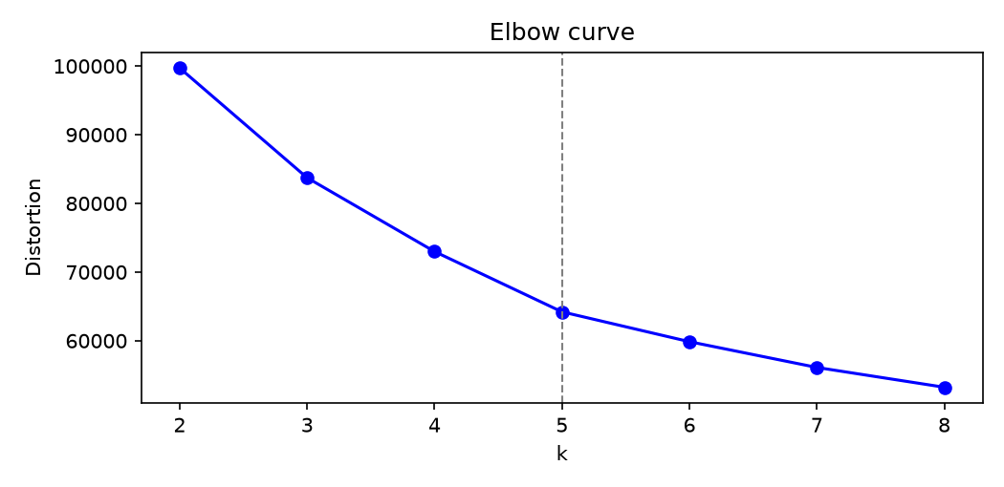
Figure 1: Elbow curve of K-Mean distortion for k=2-8 for feature set C. Dotted line indicates chosen hyperparameter k=5.

Results Exploration and Analysis

Data Preprocessing
The measurable before/after impact of our 3 chosen preprocessing steps are presented in Table 3.
Table 3: Measurable before/after impact of the three selected preprocessing steps.
Candidate step | Before | After
Deriving days_since_last_review from last_review | last_review missing for 4,477 rows, could not derive missing values | days_since_last_review filled with 4,594 days for missing last_review rows. 0 missing rows with median 84 days.
Calculate amenity_count by parsing the structured amenities field | No field exists describing the amenity count of a particular listing. | New amenity_count field derived from parsing the amenities field, with counts matching the JSON array length.
Handle missing price values via median imputation plus a missing indicator variable | 25.47% of prices missing, and the missingness is not random | 0% prices missing, imputed using median $243.67. Derived price_missing feature indicates every imputed row.

Correlation Analysis
Table 4 reports Pearson, Spearman, MI and NMI for all 10 pairs.
Table 4: Pairwise Pearson correlation, Spearman correlation, MI (bits) and NMI for every pair of the five variables (n=21,251 listings with at least one review)
Pair | Pearson | Spearman | MI (bits) | NMI | Bins
days_since_last_review ~ availability_365 | −0.438 | −0.395 | 0.1829 | 0.0856 | 10×8
days_since_last_review ~ host_is_superhost | −0.337 | −0.443 | 0.1159 | 0.0785 | 10×2
availability_365 ~ host_is_superhost | 0.146 | 0.155 | 0.0425 | 0.0324 | 8×2
host_listings_count ~ dist_cbd | −0.131 | −0.225 | 0.0580 | 0.0285 | 7×10
host_listings_count ~ days_since_last_review | −0.113 | −0.194 | 0.0558 | 0.0274 | 7×10
host_listings_count ~ availability_365 | 0.059 | 0.225 | 0.0430 | 0.0230 | 7×8
availability_365 ~ dist_cbd | 0.170 | 0.124 | 0.0315 | 0.0147 | 8×10
days_since_last_review ~ dist_cbd | −0.081 | 0.061 | 0.0317 | 0.0138 | 10×10
host_listings_count ~ host_is_superhost | −0.069 | 0.070 | 0.0117 | 0.0097 | 7×2
dist_cbd ~ host_is_superhost | 0.076 | 0.009 | 0.0070 | 0.0047 | 10×2
The two methods disagree on host_listings_count with the target, where Pearson is −0.069 and Spearman is +0.070, because the relationship rises and then falls rather than moving in one direction. This pattern is shown in Figure 2.

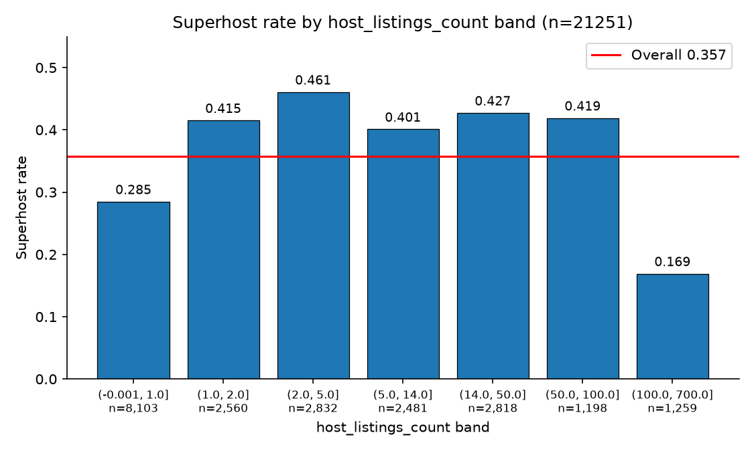
Figure 2: Superhost rate by host_listings_count band (n = 21,251 reviewed listings). The red line marks the overall superhost rate of 0.357. The rate climbs from 28.48% at one listing or fewer to 46.08% at three to five listings, then falls to 16.92% above 100.

Supervised Learning Models and Evaluation
5-fold stratified cross-validation F1 scores per hyperparameter value are reported in Table 5.
Table 5: Cross-validated F1 score at every hyperparameter value tried (five grouped folds, 20,582 training listings). Selected configurations shaded blue.
K-NN |  | Decision Tree
k | CV F1 Score | max_depth | CV F1 Score
1 | 0.4802 ± 0.0175 | 2 | 0.5158 ± 0.0503
5 | 0.5020 ± 0.0159 | 3 | 0.5611 ± 0.0431
11 | 0.5071 ± 0.0176 | 4 | 0.5712 ± 0.0177
21 | 0.5190 ± 0.0112 | 5 | 0.5384 ± 0.0424
51 | 0.5299 ± 0.0121 | 6 | 0.5512 ± 0.0240
101 | 0.5370 ± 0.0133 | 8 | 0.5622 ± 0.0123
151 | 0.5312 ± 0.0147 | 10 | 0.5745 ± 0.0130
201 | 0.5309 ± 0.0175 | 15 | 0.5363 ± 0.0171
301 | 0.5249 ± 0.0226 | None† | 0.5018 ± 0.0072
† None means unlimited depth.
Cross-validation results compared to default hyperparameters are reported in Table 6.
Table 6: Cross-validation results per hyperparameter value changed from default, and effect on mean 5-fold CV F1 score.
Model | Hyperparameter | Default | Chosen | Default CV F1 | Chosen CV F1 | Effect
K-NN | Number of neighbors (k) | k = 5 | k = 101 | 0.5020 | 0.5370 | +0.0350
Decision Tree | Maximum depth of tree (max_depth) | max_depth = None | max_depth  = 10 | 0.5018 | 0.5745 | +0.0727
Test-set performance is reported in Table 7.
Table 7: Test-set performance (n=5,146), with precision, recall, accuracy and F1 scores.
Model | Class | Precision | Recall | Accuracy | F1 Score
Baseline | Non-superhost | 0.6935 | 1.0000 | 0.6935 | 0.8190
 | Superhost | 0.0000 | 0.0000 | 0.6935 | 0.0000
k-NN (k=101) | Non-superhost | 0.8106 | 0.8322 | 0.7487 | 0.8212
 | Superhost | 0.5958 | 0.5599 | 0.7487 | 0.5773
Decision Tree (depth=10) | Non-superhost | 0.8445 | 0.8067 | 0.7629 | 0.8252
 | Superhost | 0.6028 | 0.6639 | 0.7629 | 0.6319
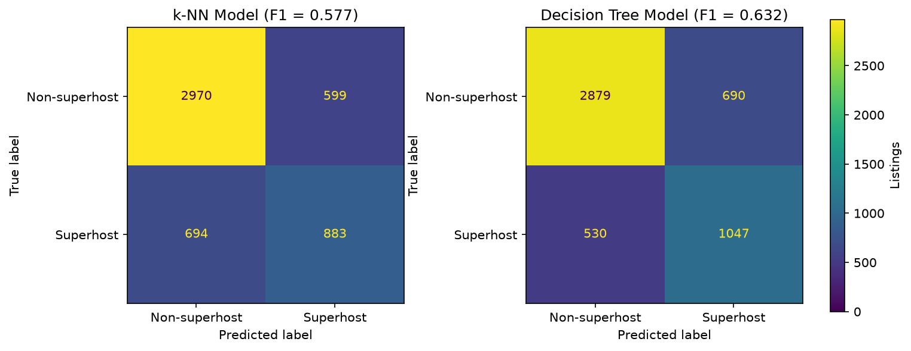
Figure 3: Confusion matrices for both models on the test set (n=5146). Of the 1,577 test superhosts, k-NN finds 883 and the tree finds 1047.

Table 8 gives the 95% bootstrap interval for each model, for the gap between them, and for the feature-subset comparisons.
Table 8: 95% confidence intervals for both models including feature-subset experiments. Paired host bootstrapping, 1,000 resamples.
Model/Pair | 95% CI
k-NN | [0.5423, 0.6155]
Decision Tree | [0.5940, 0.6757]
DT - k-NN | [0.0130, 0.0986]
A (fundamentals) | [0.1535, 0.2384]
B (operational) | [0.5981, 0.6844]
B - A | [0.3813, 0.5046]
F (operational, no review pair) | [0.4923, 0.6313]
F - A | [0.2819, 0.4536]

Feature Selection
Top features from each method. Table 9 reports the three highest ranked features under mutual information and under feature importance, with the corresponding values. Figure 4 shows the tree's importance across all 11 features.
Hard case. The tree's most confident miss is listing 6812677, a superhost it classified as a non-superhost with a probability of 0.000. It is one of 530 false negatives, and Table 10 compares its attributes against the median of each class.
Table 9: Top 3 features from the filter (mutual information) and embedded (decision tree Importance) methods.
Feature | Filter rank (MI) | MI | Embedded rank (feature importance) | Importance
days_since_last_review | 1 | 0.1273 | 1 | 0.5005
host_listings_count | 2 | 0.1087 | 2 | 0.2698
availability_365 | 3 | 0.0759 | 4 | 0.0356
amenity_count | 4 | 0.0749 | 3 | 0.1023
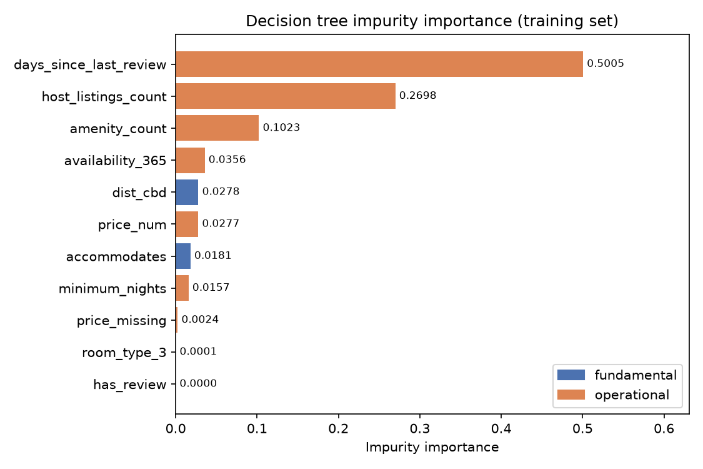
Figure 4: Decision tree impurity importance for all 11 features, coloured by family, computed on the 20,582 training listings. days_since_last_review alone accounts for 0.5005 of the total.

Table 10: Hard-case listing 6812677 compared against class medians
Outcome | days_since_last_review | amenity_count | availability_365 | host_listings_count | dist_cbd | accommodates | price_num | minimum_nights | has_review | price_missing
Listing 6812677 (false negative) | 156 | 18 | 116 | 1 | 3.71 | 4 | 261 | 2 | 1 | 0
Superhost median | 37 | 45 | 195 | 3 | 4.64 | 4 | 252 | 2 | 1 | 0
Non-superhost median | 468 | 32 | 124 | 2 | 4.92 | 3 | 240 | 2 | 1 | 0

Dimensionality Reduction & Clustering
PCA. PCA was run on the standardised six-feature set. The first three components carry 69.4% of the variance between them, and Table 11 reports the explained variance and the top loadings. Figure 5 plots the listings against the first two components.
Table 11: PCA on standardised set C, containing explained variance ratio (EVR), cumulative variance and top 3 loadings.
Component | EVR | Cumulative | Rank 1 | Rank 2 | Rank 3
PC1 | 0.3211 | 0.3211 | days_since_last_review +0.563 | amenity_count −0.504 | availability_365 −0.447
PC2 | 0.2045 | 0.5255 | dist_cbd +0.786 | host_listings_count −0.556 | accommodates +0.208
PC3 | 0.1681 | 0.6936 | accommodates +0.671 | availability_365 −0.591 | amenity_count +0.355
Cluster profiles. Tables 12 and 13 give the size, superhost rate and median feature values of every cluster under each method.
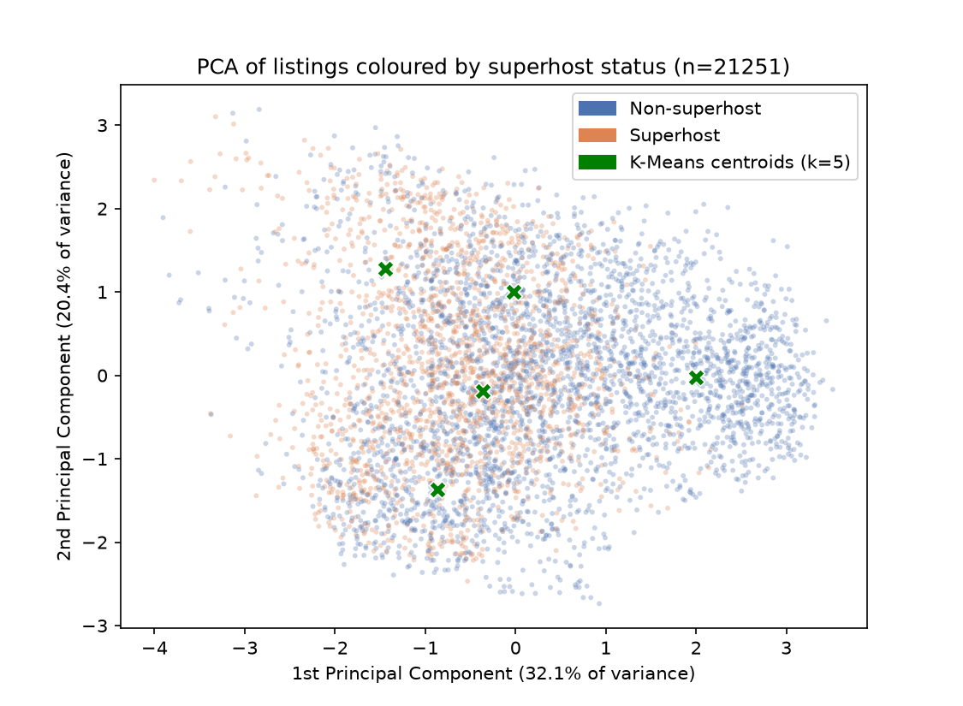
Figure 2: PCA scatter of the 21,251 reviewed listings on the first two components, coloured by superhost status, with K-Means centroids (k=5) marked. A random sample of 5,000 listings is shown.
Table 12: K-Means cluster profiles (k=5) on the standardised six-feature set. Feature values are medians.
# | Listings | Share | Superhost rate | dist_cbd | accommodates | availability_365 | amenity_count | days_since_last_review | host_listings_count
1 | 4,541 | 21.4% | 35.3% | 1.42 | 4 | 188 | 41 | 50 | 50
2 | 5,340 | 25.1% | 53.9% | 2.25 | 4 | 157 | 47 | 40 | 2
3 | 4,689 | 22.1% | 6.8% | 4.54 | 2 | 0 | 23 | 1,883 | 1
4 | 2,365 | 11.1% | 43.7% | 20.56 | 8 | 218 | 51 | 58 | 3
5 | 4,316 | 20.3% | 40.7% | 17.82 | 2 | 310 | 33 | 76 | 2
Table 13: Hierarchical (Ward) cluster profiles at the same k=5. Feature values are medians.
# | Listings | Share | Superhost rate | dist_cbd | accommodates | availability_365 | amenity_count | days_since_last_review | host_listings_count
1 | 8,256 | 38.9% | 49.9% | 5.36 | 4 | 174 | 47 | 56 | 1
2 | 3,829 | 18.0% | 30.1% | 7.32 | 2 | 267 | 22 | 100 | 3
3 | 4,716 | 22.2% | 37.5% | 1.79 | 4 | 175 | 42 | 55 | 45
4 | 3,249 | 15.3% | 2.9% | 4.34 | 2 | 0 | 20 | 2,364 | 1
5 | 1,201 | 5.7% | 37.8% | 17.55 | 10 | 221 | 49 | 49 | 12

Discussion and Interpretation

Data Preprocessing
The three preprocessing steps differ in their implications for the research question. For Step 1, the key implication is the 4,477 zero-review listings: their superhost rate is 6.59% against 35.72% for reviewed listings, and deleting them would inflate the positive rate from 30.65% to 35.72%. For amenity_count, 12.03% of rows differ between naive and correct parsing and the superhost gap (13.05 amenities) is far smaller than the review-recency gap, so the information is complementary. For price, missingness itself is meaningful, as delisted listings have a superhost rate of 8.13% versus 37.68% for active listings, so the feature is useful.

Correlation Analysis
Agreement and divergence. Pearson and Spearman agree closely on the strongest pair, days_since_last_review with availability_365 (−0.438 vs −0.395). They point in opposite directions on two pairs (Table 4). days_since_last_review with dist_cbd gives Pearson −0.081 and Spearman +0.061, and host_listings_count with the target gives −0.069 and +0.070.
The host_listings_count case is explainable from the data. Pearson measures a straight-line relationship while Spearman measures one that moves in a consistent direction, and this relationship does neither, because it rises and then falls (Figure 2). The superhost rate is 28.48% for hosts with one listing or fewer (n = 8,103), peaks at 46.08% for hosts with three to five listings (n = 2,832), and drops to 16.92% for hosts with more than 100 (n = 1,259). A rise followed by a fall doesn’t model a linear relationship, so Pearson correlation gives a weak measure. Spearman also gives a weak reading due to the data being non-monotonic.
Connection to the RQ. Of the four pairs ranked by NMI, days_since_last_review has the strongest association (NMI 0.0785), followed by availability_365 (0.0324) and host_listings_count (0.0097). dist_cbd comes last (0.0047), so the only listing fundamentals feature in the set has the weakest association with the target. It is important to note that these are associations only. Hosts with more than 100 listings may be running business or apartment models, so their low rate may reflect the business, rather than service quality. The 21,251 listings come from 11,474 hosts, so the observations are not independent. Not every guest also leaves a review, so days_since_last_review may be inaccurate. The exploratory set is also uneven, with three operational variables against one fundamental. This imbalance is why the supervised stage ran the feature-subset experiments, where the two families are scored on equal terms.

Supervised Learning Models and Evaluation
Model performance. With the official criteria excluded, the tree reaches a test F1 of 0.632 on the superhost class and k-NN 0.577, against a majority-class baseline of exactly 0. The baseline model that ignores every feature already reaches 0.694 accuracy, which is just the non-superhost share restated (1 − 0.3065 = 0.6935), thus making accuracy not important. Using superhost F1 scores, we can conclude that superhost status can be inferred from the listing record once the criteria are removed. The tree finds 1,047 of the 1,577 test superhosts and misses 530, a recall of 0.664, while k-NN misses 694. Both models perform much better on non-superhosts, where the decision tree reaches 0.845 precision.
Comparing the models. The decision tree is the stronger of the two. Its paired bootstrap interval against k-NN is [0.0130, 0.0986], which does not include zero, so the difference is unlikely to be sampling noise. The tree does predict superhost more often, which is double-sided: it predicts 1,047 superhosts compared to K-NN's 883, but it also predicts 690 false positives against K-NN's 599.
Subset experiments and the RQ. The subset experiments answer the research question most directly. Listing fundamentals variables on their own reach 0.166 CV F1, while operational features reach 0.548, with the paired interval for that difference being [0.3813, 0.5046], which does not include zero. One caveat is that the operational group has eight features and the fundamentals group has three, so part of the gap may simply reflect that a larger set can hold more information.

Feature Selection
Agreements and divergence. Both methods put days_since_last_review first and host_listings_count second. The first is expected, given how strongly it is associated with the target. The methods disagree on third place. Mutual information scores each feature against the target on its own, so availability_365 appears to be highly scored at 0.0759, with amenity_count just behind at 0.0749. Feature importance works differently: it credits a feature only for the tree impurity it removes once the earlier splits are already in place. availability_365 carries much the same information as days_since_last_review, so once the tree has split on recency there is little left for it to explain, and it drops to 0.0356. amenity_count overlaps with recency far less, so it keeps 0.1023. Experiment E supports this reading: removing availability_365 leaves CV F1 slightly higher (0.5846 vs 0.5745) and test F1 essentially unchanged (0.6303 vs 0.6319).
The hard case. Listing 6812677 is a superhost that the tree classed as a non-superhost with a predicted probability of 0.000, making it one of 530 false negatives. On the features the model can see it looks dormant: 18 amenities against medians of 45 for superhosts and 32 for non-superhosts, availability of 116 which is below even the non-superhost median of 124, a host with a single listing, and 156 days since the last review against a superhost median of 37. What the model couldn’t see is that the listing has 195 reviews. Review volume is one of the excluded criteria, so the tree knows only that the last review was 156 days ago and reads that as decline.

Dimensionality Reduction & Clustering
PCA. PC1 carries 32.1% of the variance, and its three largest loadings are all operational: days_since_last_review (+0.563), amenity_count (−0.504) and availability_365 (−0.447). PC2 carries 20.5% and compares dist_cbd (+0.786) against host_listings_count (−0.556), which separates distance from the CBD from the size of the host's portfolio. PC3 carries 16.8% and compares accommodates (+0.671) against availability_365 (−0.591).
K-Means. K-Means separated one group sharply and left the other four near the 35.72% base rate. Cluster 3 holds 22.1% of listings, with a median of 1,883 days since the last review, zero availability across the year, one listing, 23 amenities, and a superhost rate of 6.8%. Cluster 2 sits at the opposite end, with 40 days since the last review, 47 amenities and a rate of 53.9%. The remaining three stay close to the base rate, at 35.3%, 43.7% and 40.7%, and differ from each other mainly in location and size: cluster 1 is a group of large operators with a median of 50 listings 1.4 km from the CBD, cluster 4 is larger homes at 20.6 km, and cluster 5 is small listings at 17.8 km with 310 available days.
Connection to the RQ. PCA shows that the axis that explains the most is operational, which agrees with the supervised result that fundamentals alone reach 0.166 CV F1 against 0.548 for operational features. Location is not absent, though, since dist_cbd dominates the second axis. The accurate claim is that the largest single axis is operational and the second is geographic. K-Means shows that one group separates, not that all five differs. It shows that activity, not location, is what makes a listing distinguishable.

Limitations and Improvement Opportunities

Preprocessing
Price imputation assigns the global median of $243.67 to 6,553 missing rows, and 93.35% of those are listings that are unavailable all year. Their true prices may be higher or lower, and price_missing records that a value was imputed without recovering it. Ten subsamples of 75% of the data give medians between $243.0 and $245.0, a spread under 1%, so the global median carries only minor leakage. Separately, amenity_count treats every amenity as equally important, so a Wi-Fi router and a pool contribute the same amount.

Correlation
Observations are not independent. The 21,251 reviewed listings come from 11,474 hosts, and a host's status is the same across all of their listings, so the effective sample is smaller than the row count suggests. At this size almost any coefficient would be significant, so the interpretation rests on effect size rather than on significance.
MI depends on the number of bins. For days_since_last_review with availability_365, MI rises from 0.1175 at five bins to 0.2499 at twenty, an increase of 113%, while NMI moves only from 0.0799 to 0.0896, or 12%. Comparisons between pairs therefore use NMI.

Supervised Learning
The classes are imbalanced. Superhosts are 30.65% of listings, so accuracy is a poor guide and a majority-class classifier already reaches 0.694. Recall on the superhost class is the weak point, at 0.664 for the tree and 0.560 for k-NN.
Only the depth is changing. For decision trees, max_depth is set to 10 and min_samples_leaf was left at its default of 1, so a leaf can hold a single listing. Nothing other than depth constraints how finely the tree splits.
The two feature groups are different sizes. Operational features number eight against three fundamentals, so part of the gap between them may reflect the larger set holding more information rather than that family being more informative. Set F, with six features, only partly addresses this.

Feature Selection
Continuous features are favored. A continuous feature offers more possible split points, so it has more chances to reduce impurity. For instance, dist_cbd ranks 5th by embedded importance at 0.0278 while the filter places it 8th at MI 0.0340.
Third place is very close. availability_365 and amenity_count differ by 0.0010 on MI (0.0759 vs 0.0749), so a different fold split could reverse the fickle order.

PCA & Clustering
Much of the variance is unexplained. The first three components carry 69.4%, leaving 30.6% that none of the interpretations above covers, and PC1 alone accounts for 32.1%.
The result depends on scaling. The clustering input was log-transformed on the three skewed features and then standardised, which gives every feature the same weight. That is what allows accommodates, which ranges from 1 to 16, to count as heavily as days_since_last_review, which ranges from 0 to 4,593. A PCA on the correlation matrix of the untransformed features would produce different components, and the cluster boundaries would move with them.
k was chosen by eye. k=5 was read from the bend in the elbow curve. Distortion falls for every extra cluster, so there is no minimum to look for, and k=4 and k=5 are close at 72,991.5 and 64,211.4. The value was chosen because the cluster profiles separate more cleanly at 5 than at 4, not because a test selected it. A gap statistic could be computed to confirm that k=5 is a good option.

Conclusion
The report investigates whether superhost status be inferred from listing attributes and host operating behaviour once Airbnb's own criteria are excluded, and whether it more closely associated with listing fundamentals or operational strategy. Superhost status is partly inferable from the listing record once Airbnb's own criteria are removed, and the inferable part is operational rather than fundamental. Preprocessing established the stake, since the 4,477 listings with no review carry a 6.59% superhost rate against 35.72% for reviewed listings. Correlation reached the same conclusion, with distance from the CBD the weakest of all ten pairs at NMI 0.0047 while review recency reached 0.0785 against the target. Both feature-selection methods ranked days_since_last_review and host_listings_count first and second, and the subset experiments settled the comparison: a decision tree on fundamentals alone reached 0.1658 CV F1 against 0.5484 for operational features, a paired gap of [0.3813, 0.5046] excluding zero, while all 11 features reached 0.5745 CV and 0.6319 test F1 against a 0.0 baseline. Clustering supports our conclusion, with PC1 taking 32.1% of the variance and K-Means isolating 4,689 dormant listings at a 6.8% superhost rate. Superhost status is inferable, but not entirely, as 118 of the 124 test superhosts inactive over a year went undetected.
References
Inside Airbnb. (2026). Melbourne, Victoria, Australia. Retrieved October 2, 2026 from http://insideairbnb.com/get-the-data/
How to become a Superhost - Airbnb Help Centre. (n.d.). Airbnb. Retrieved October 2, 2026, from https://www.airbnb.com.au/help/article/829

